
Westvlietweg 72 X
2495 AA Den Haag, NL
e-mail info@skygliders.nl
www.skygliders.nl
phone +31.6.2453.2026

P A R A G L I D E R S E R V I C E

owner

name
address
pc/city
county
e-mail
phone
mobile

glider
manufacturer
type
size
color
year build
purchase date new / used

serial #
accessories inner bag
harness speed rescue
backpack
owners manual

glider use free flight motor flight acro tandem

purchase check new

used

2-year check
repair, because of water- tree- leading edge landing collision
other

damage lines risers fabric top fabric bottom cross rib(s)
other

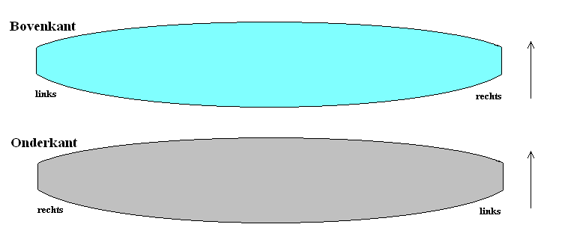

special instructions/remarks:

Do not fill out below this line – for SkyGliders use only

return to SkyGliders Paragliding send to

date prepared by Box of

